**BlockCred**

by **The Misfits**

Arpit Masih | Simran Gogia | Utkarsh Sharma

**Theme: Blockchain**

**OBJECTIVE**

A platform to securely issue and verify digital credential would go a long way to help both the issuing institutions and the receiving individuals. The lack of transparency in the issuing process, a seeming disconnect between the two ends and security loopholes all plague the various existing systems used for such credential issuing and verification.

Our platform, BlockCred is a Blockchain-powered Credential Issuing system that allows for complete transparency and authentication of such digital badges.

On the part of the institutions, it allows for a platform to fish out authenticated candidates interested in availing their services, and on the part of the candidates, it allows for a seamless process for getting rewarded.

**FEATURES**

We cater to the needs of both ends of the spectrum and put forth the following features and functionalities.

**Scalability**

* Faultless verification of credentials issued on the platform
* A suggestion contraption on the end of the issuing authorities to link them up with possible candidates based on their records
* Recommendation Systems for related certificates and credentials

**Security and Decentralised control**

* One-touch login using Blockchain wallets like Metamask to ensure for an authenticated bunch of users
* Secure and hassle-free financial transactions on Ethereum blockchain
* Hack-proof public ledger for transactions and storing credential requests

**Transparency**

* Complete transparency in an institution’s issuing record to counter any possible bias
* Public ledger for credential verification and using credentials as a verified badge of skill on other platforms like LinkedIn

**What is our Unique Selling Proposition?**

* **Including transactions within the credential system**

This gives the learner an easy and versatile platform to pay for the credentials they receive at the end of their learning pathway and the issuing authority can accept payments in a diverse range of cryptocurrencies, allowing them to reach a global audience and counter high fees associated with third-party providers and Credit Cards.

* **Smart contracts**

The structure of our *smart contract* allows only institutions to approve requests and collect the associated amount in their wallets. Ethereum blockchain allows this hack-proof solution.

* **Immutability**

Once issued, Certificates can’t be revoked or edited, guaranteeing life-long validity for the recipients. All new certificates, approvals and requests are sent through the Ethereum Consensus Mechanisms, allowing for full transparency and decentralised control.

**APP FUNCTIONALITY**

The application straight-up gives three options to the different category of users-

1. **Institutions**
2. All users can issue certificates in their name. Institutions can also see certificate requests from different students and can approve/decline requests. After this they can collect the certificate fee in their wallets and in case a request is denied, the fee is refunded.
3. Another option at their hand is to issue cashless certificates directly to a set of candidates, i.e., enter the recipient address during the time of creation, directly give them the credentials and not charge any money for these certificates.
4. **Students:** Browse, apply and pay for certificates created by institution/organisations on the platform.
5. **Verifiers:** No login required, completely gas-less transactions that anyone can use. Candidates can share the link and certificate ID with potential employers, academia or add it to their portfolio and viewers can easily verify the existence of the credential on the platform.

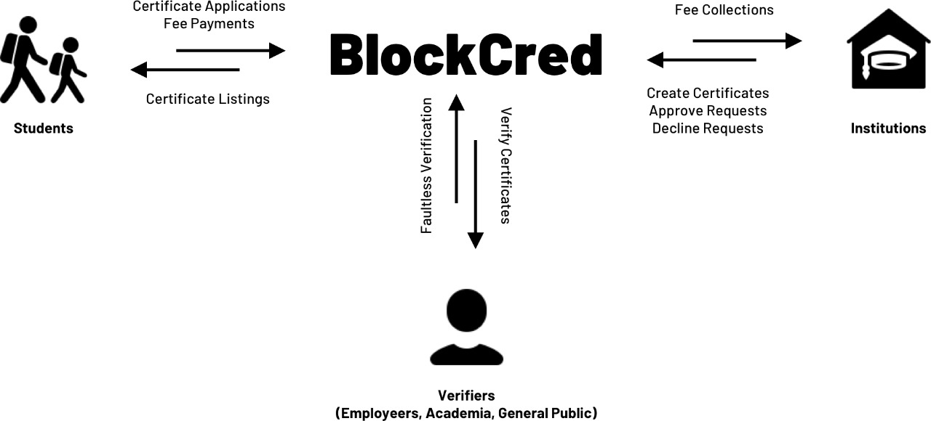

**TECHNICAL ARCHITECTURE**

BlockCred, a secure and transparent system for issuance and verification, makes use of the Ethereum blockchain and connects to it via an Infura node. The front-end MVP/POC is built using React, giving us a responsive and scalable application.

**Key frameworks:** Ganache, Truffle, Node and Infura. The platform is completely written in JavaScript and Solidity.

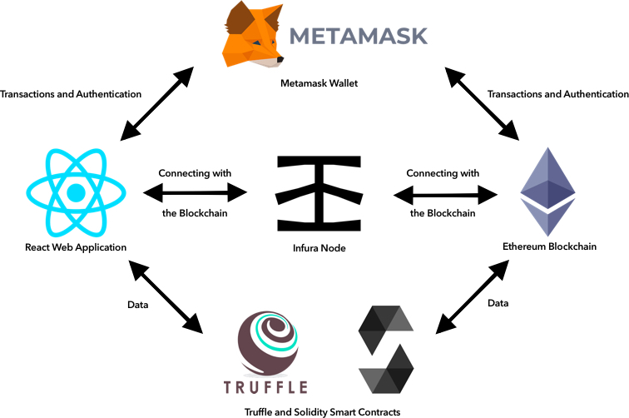

**FUTURE GOALS**

* Extending React Web Application to native Mobile Applications using libraries like web3swift and web3dart will enhance communication with the Ethereum blockchain and expand our user base.
* A wallet of our own, used for both transactions and authentication can be implemented to reduce dependency on external wallets like Metamask.
* Notably, the platform can create an ERC20 token in its name and do an ICO, offering an easy pathway for the users to pay for their learning and earn revenue for the platform as a whole. This would facilitate us into making our solution a completely free service for the issuing authorities.